

Mobile Management

WEB ENGINEERING

Project Report

Presented By:

Muhammad Umer Shaikh (CS152009)

CASE STUDY:

**Mobile Store** is the top Mobile provider company around the world. There are more than five different mobiles in the mobile store. The mobile store company wants to develop a desktop application using C sharp and Filing to maintain the records of Customer purchasing mobile. They also provide given below sample data for assistance in application development.

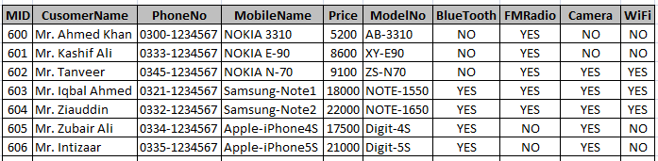

Tools used:

* Microsoft Visual Studio
* MS SQL Server

GUI:

**Login:**

User will enter email & password to login**.**

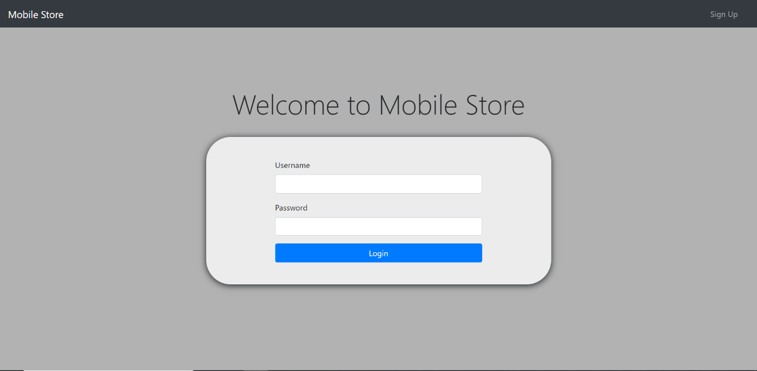

**Home:**

This is the home page of mobile management.

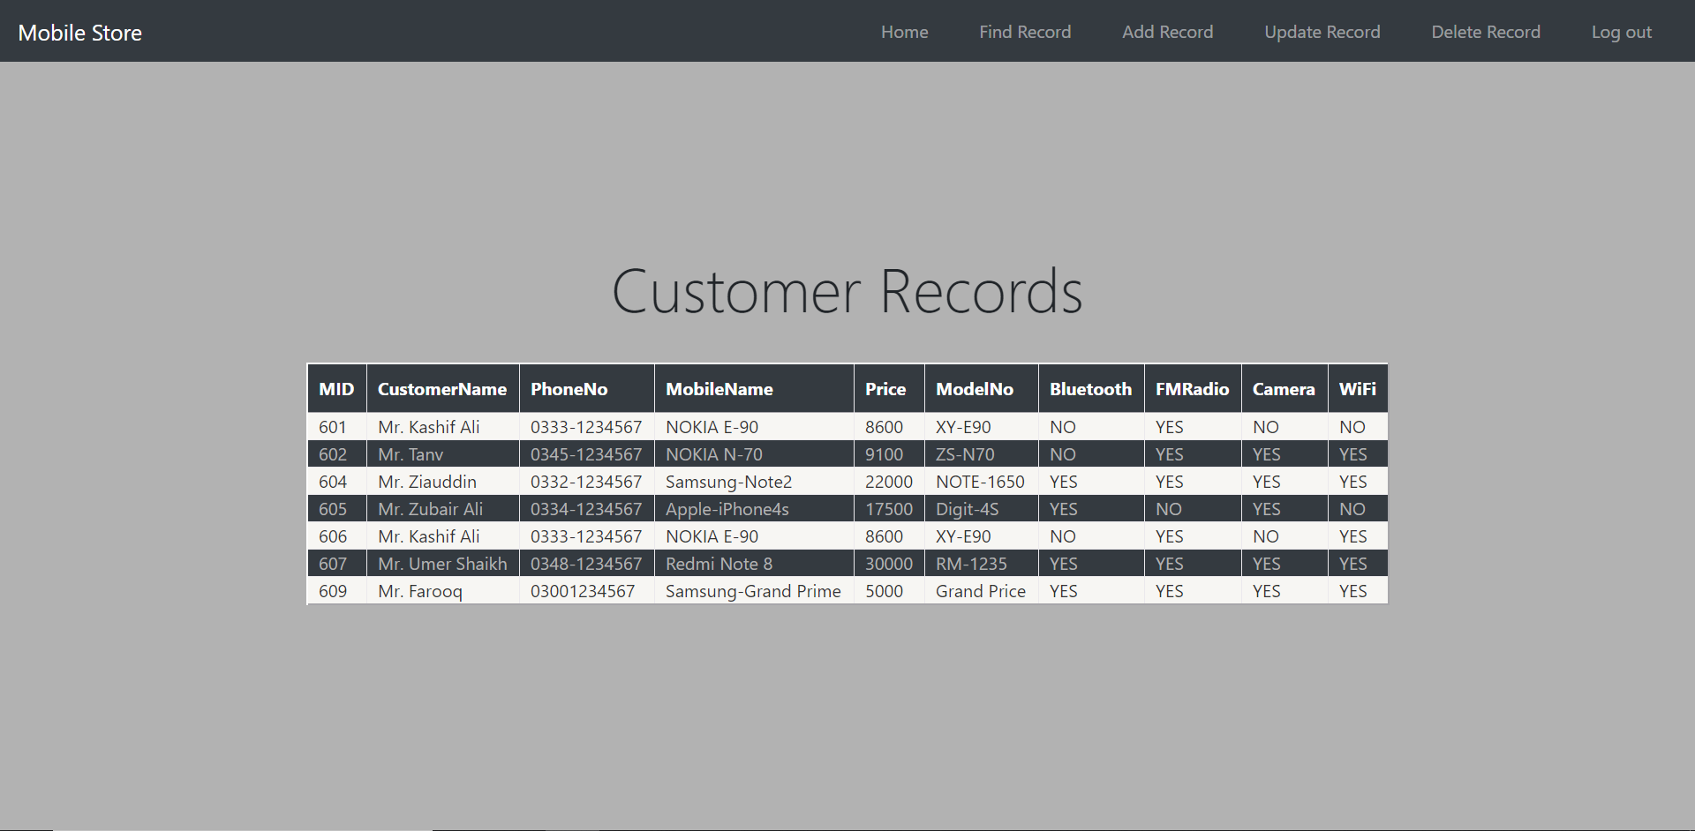

**Insert:**

Insert page of Mobile management.

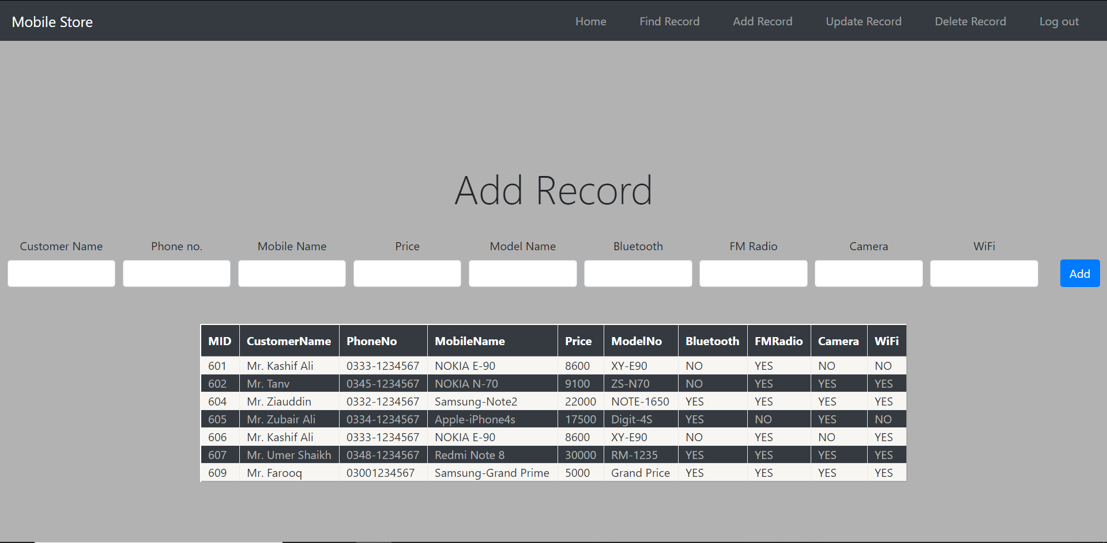

**Update:**

Update any field by entering Mobile ID.

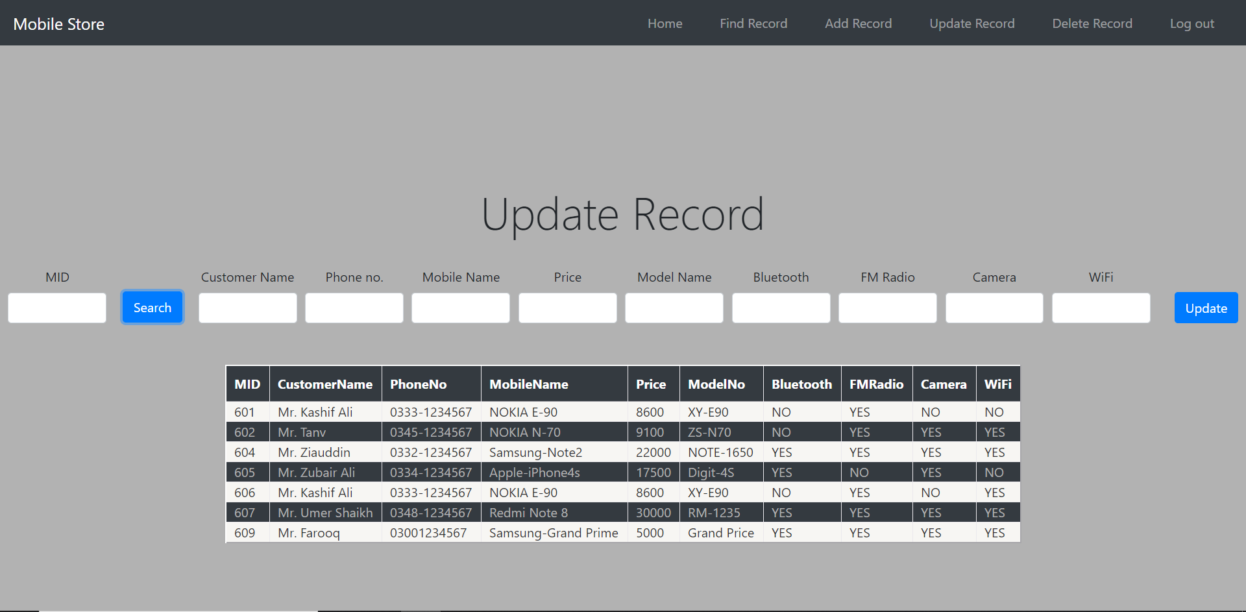

**Delete:**

Delete any record by MID.

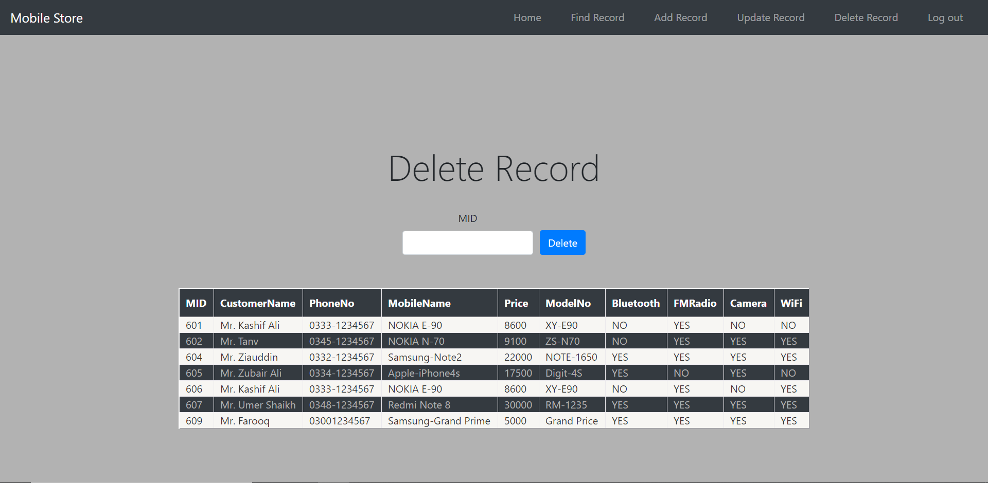

**Search:**

Search by name and phone number.

